1. Suppose A = {0,1}. Describe all strings belonging to A∗.
Ans: A∗ consists of all strings of 0s and 1s, including the empty string.

2. Suppose a phrase-structure grammar has productions S → S0, S → A1, A → 0. Find a derivation of 01.
Ans: S ⇒ A1 ⇒ 01.

3. Suppose a phrase-structure grammar has productions S → S0, S → A1, A → 0. Find a derivation of 0100.
Ans: S ⇒ S0 ⇒ S00 ⇒ A100 ⇒ 0100.

4. Suppose a phrase-structure grammar has productions S → S0, S → A1, A → 0. Find a derivation of 010.
Ans: S ⇒ S0 ⇒ A10 ⇒ 010.

5. Suppose a phrase-structure grammar has productions S → 1S0, S → 0A, A → 0. Find a derivation of 00.
Ans: S ⇒ 0A ⇒ 00.

6. Suppose a phrase-structure grammar has productions S → 1S0, S → 0A, A → 0. Find a derivation of 1000.
Ans: S ⇒ 1S0 ⇒ 10A0 ⇒ 1000.

7. Suppose a phrase-structure grammar has productions S → 1S0, S → 0A, A → 0. Find a derivation of 110000.
Ans: S ⇒ 1S0 ⇒ 11S00 ⇒ 110A00 ⇒ 110000.

8. Suppose a phrase-structure grammar has productions S → S11, S → 0A, S → A1, A → 0. Find a derivation of 01.
Ans: S ⇒ A1 ⇒ 01.

9. Suppose a phrase-structure grammar has productions S → S11, S → 0A, S → A1, A → 0. Find a derivation of 0011.
Ans: S ⇒ S11 ⇒ 0A11 ⇒ 0011.

10. Suppose a phrase-structure grammar has productions S → S11, S → 0A, S → A1, A → 0. Find a derivation of 011111.
Ans: S ⇒ S11 ⇒ S1111 ⇒ A11111 ⇒ 011111.

11. Find a production of the form “A →________ ” such that S → 0A, A →________ produces {00}.
Ans: A → 0.

12. Find a production of the form “A →________ ” such that S → 1S, S → 0A, A →________ produces {1^{n}00 | n ≥ 0}.
Ans: A → 0.

13. Find a set of two productions that produces {1^{2n} | n > 0}.
Ans: S → S11, S → 11.

14. Let G be the phrase-structure grammar with vocabulary V = {A,B,a,b,S}, terminal element set T = {a,b}, start symbol S, and production set P = {S → ABa,S → Ba,A → aB,AB → b,B → ab}. Which of these are derivable from ABa?
A) ba B) abb C) aba D) b E) aababa F) A and E
Ans: F

15. Let G be the phrase-structure grammar with vocabulary V = {A,B,a,b,S}, terminal element set T = {a,b}, start symbol S, and production set P = {S → ABa,S → Ba,A → aB,AB → b,B → ab}. Which of these are derivable from A?
A) babaa B) aab C) bba
Ans: B

16. Let G be the phrase-structure grammar with vocabulary V = {A,B,a,b,S}, terminal element set T = {a,b}, start symbol S, and production set P = {S → ABa,S → Ba,A → aB,AB → b,B → ab}. Which of these are derivable from S?
A) ba B) ab C) baab D) aababa E) aba F) A, D, and E G) A and E
Ans: F

17. Let G be the phrase-structure grammar with vocabulary V = {A,B,0,1,S}, terminal elements T = {0,1}, start symbol S, productions P = {S → AB0,AB → 1,A → 0,B → AB}. Which of these are derivable from S?
A) 000 B) 11 C) 0000 D) 0001 E) 110 F) Both 010 and 0111
Ans: F

18. Suppose V = {S,A,a,b}, T = {a,b}, and S is the start symbol. Find a set of productions that includes S → Aa and A → a and generates the language {a,aa}.
Ans: S → Aa, A → a, S → a.

19. Suppose V = {S,A,a,b}, T = {a,b}, and S is the start symbol. Find a set of productions that includes S → Aa and A → a and generates the language {a,b,ba,baa}.
Ans: S → Aa, A → a, S → aA, A → ab.

20. The productions of a phrase-structure grammar are S → S1, S → 0A, A → 1. Find a derivation of 0111.
Ans: Apply the production S → S1 twice to obtain S11. Then apply S → 0A to obtain 0A11. Then apply A → 1 to obtain 0111.

21. What language is generated by the phrase-structure grammar if the productions are S → S11, S → λ, where S is the start symbol?
Ans: The language generated is the set of all strings consisting of an even number of 1s and no other symbols.

22. What is the language generated by the grammar with productions S → SA, S → 0, A → 1A, and A → 1, where S is the start symbol?
Ans: The set of all bit strings that consist of a 0 followed by an arbitrary number of 1s.

23. Find a grammar for the set {0^{2n}1^{n} | n ≥ 0}.
Ans: Use the grammar with productions S → 00S1 and S → λ, where S is the start symbol.

Use the following to answer questions 24-29:

In the questions below let V = {S,A,B,0,1} and T = {0,1}. For each set of productions determine whether the resulting grammar G is
(i) type 0 grammar, but not type 1,
(ii) type 1 grammar, but not type 2,
(iii) type 2 grammar, but not type 3,
(iv) type 3 grammar.

24. S → A10, AB → 0.
Ans: i.

25. S → B, A → B, B → A.
Ans: iii.

26. S → AB, A → 0B1, 0B1 → 0.
Ans: i.

27. S → 1A, A → 1, S → λ.
Ans: iv.

28. S → 1AB, AB → 0B, B → 0, A → 1B.
Ans: ii.

29. S → 0B, B → 1A, B → 0, A → 0B.
Ans: iv.

30. Construct a finite-state machine that models a vending machine accepting only quarters that gives a container of orange juice when 50 cents has been deposited, followed by a button being pushed. (The possible inputs are quarters and the button, and the possible outputs are nothing, orange juice, and a quarter. The machine returns any extra quarters.)
Ans:
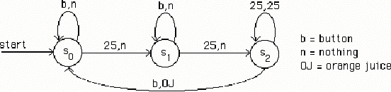

31. What is the output produced by the following finite-state machine when the input string is 11101?
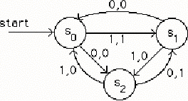
Ans: 10000.

32. Construct a finite-state machine with output that produces a 1 if and only if the last 3 input bits read are 0s.
Ans:
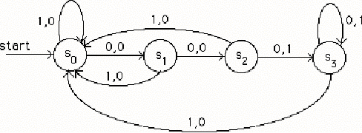

33. Suppose that A = {1,11,01} and B = {0,10}. Find AB.
Ans: AB = {10,110,1110,010,0110}.

34. Suppose that A = {1,11,01} and B = {0,10}. Find BA.
Ans: BA = {01,011,001,101,1011,1001}.

Use the following to answer questions 35-38:

In the questions below determine the output for each input string, using this state table.
 | f |  | g
 | input: |  | input:
 | 0 | 1 | 0 | 1
s₀ | s₁ | s₂ | 1 | 1
s₁ | s₂ | s₀ | 0 | 0
s₂ | s₁ | s₃ | 1 | 1
s₃ | s₃ | s₁ | 0 | 1

35. 1111.
Ans: 1110.

36. 10111.
Ans: 11011.

37. 000.
Ans: 101.

38. 11000.
Ans: 11000.

39. Let A = {1,10}. Which strings belong to A∗?
Ans: The strings in A∗ are those in which each 0 is preceded by at least one 1.

40. Find the set recognized by the following deterministic finite-state machine.
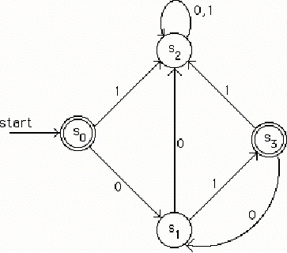
Ans: The set represented by (01)∗.

41. Find all strings recognized by the following deterministic finite-state automaton.
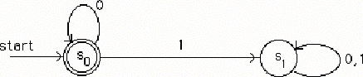
Ans: All bit strings with no 1s.

42. Find all strings recognized by the following deterministic finite-state automaton.
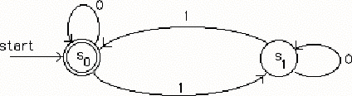
Ans: All bit strings with an even number of 1s.

43. Find the language recognized by the following nodeterministic finite-state automaton.
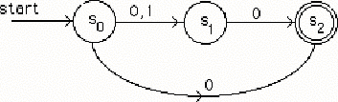
Ans: {0,00,10}.

44. Find the language recognized by the following nodeterministic finite-state automaton.
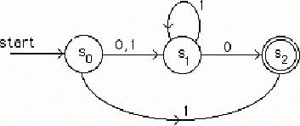
Ans: {1,01^{n}0,1^{n}0 | n ≥ 0}.

45. Let A = {0,11}. Find A².
Ans: {00,011,110,1111}.

46. Let A = {0,11}. Find A³.
Ans: {000,0011,01111,0110,1100,11011,11110,111111}.

47. Find the Kleene closure of A = {1}.
Ans: {1^{n} | n = 0,1,2,…}.

48. Find the Kleene closure of A = {00}.
Ans: {0^{2n} | n = 0,1,2,…}.

49. Find the Kleene closure of A = {0,1,2}.
Ans: All strings of 0s, 1s, and 2s.

50. Which strings belong to the set represented by the regular expression 0∗ ∪ 11?
Ans: The bit strings consisting of all 0s (including the empty string) and the string 11.

51. Construct a finite-state automaton that recognizes all strings that end with 11.
Ans:
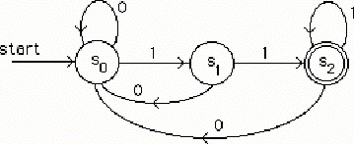

52. Construct a finite-state automaton that recognizes the set represented by the regular expression 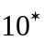.
Ans:
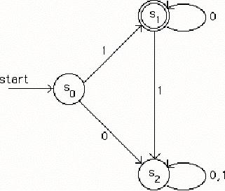

53. Find a deterministic finite-state automaton equivalent to the following nondeterministic finite-state machine.
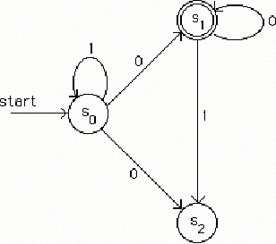
Ans:
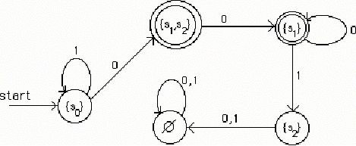

54. Which strings belong to the regular set represented by the regular expression (1∗01∗0)?
Ans: The strings containing an even number of 0s and not ending with a 1.

55. Determine if 1101 belongs to the regular set 1*0*1.
Ans: Yes.

56. Determine if 1101 belongs to the regular set (0 ∪1)*1.
Ans: Yes.

57. Determine if 1101 belongs to the regular set (11)*0*(11)*.
Ans: No.

58. Determine if 1101 belongs to the regular set 1(10)*1*.
Ans: Yes.

59. Determine if 1101 belongs to the regular set (01)*(11)*(01)*.
Ans: Yes.

60. Determine if 1101 belongs to the regular set 11(00)*(10)*.
Ans: No.

61. Determine if 1101 belongs to the regular set (111)*(01)*.
Ans: No.

62. Which strings are recognized by the following finite-state automaton?
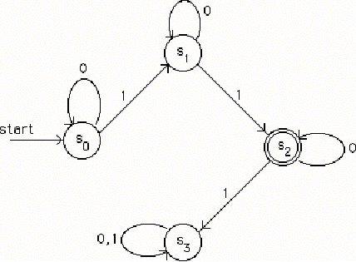
Ans: Strings containing exactly two 1s.

63. For the following Turing machines T, find the final tape when T is run on the following tape, beginning in the initial position (the first nonzero entry from the left):
... | B | B | 0 | 0 | 0 | 1 | B | 0 | B | B | ...
(s₀,0,s₀,0,R), (s₀,1,s₁,0,R), (s₁,0,s₁,1,R), (s₁,1,s₂,1,L), (s₁,B,s₁,1,L).
Ans:
... | B | B | 0 | 0 | 0 | 1 | 1 | 0 | B | B | ...

64. For the following Turing machine T, find the final tape when T is run on the following tape, beginning in the initial position (the first nonzero entry from the left):
... | B | B | 0 | 0 | 0 | 1 | B | 0 | B | B | ...
(s₀,0,s₀,1,R), (s₀,1,s₁,0,R), (s₁,1,s₂,1,R), (s₁,B,s₀,0,R).
Ans:
... | B | B | 1 | 1 | 1 | 0 | 0 | 1 | B | B | ...

65. For the following Turing machine T, find the final tape when T is run on the following tape, beginning in the initial position (the first nonzero entry from the left):
... | B | B | 0 | 0 | 0 | 1 | B | 0 | B | B | ...
(s₀,0,s₁,1,R), (s₀,1,s₁,1,L), (s₁,0,s₀,1,L).
Ans: ... | B | B | 1 | 1 | 0 | 1 | B | 0 | B | B | ...

66. For the following Turing machine T, find the final tape when T is run on the following tape, beginning in the initial position (the first nonzero entry from the left):
... | B | B | 0 | 0 | 0 | 1 | B | 0 | B | B | ...
(s₀,0,s₂,0,R), (s₀,B,s₀,1,R), (s₁,0,s₂,1,R), (s₂,0,s₁,1,L), (s₂,1,s₀,1,R) .
Ans:
... | B | B | 1 | 1 | 0 | 1 | 1 | 0 | B | B | ...

67. Consider the Turing machine T: (s₀,0,s₁,1,R), (s₀,1,s₁,1,R), (s₁,0,s₀,1,L), (s₁,1,s₀,0,R), (s₀,B,s₁,1,R). For the following tape, determine the final tape when T halts, assuming that T begins in state s₀ at the leftmost nonblank symbol.
... | B | B | 1 | 1 | 0 | B | B | ...

Ans:
... | B | B | 1 | 0 | 1 | B | B | ...

68. Consider the Turing machine T: (s₀,0,s₁,1,R), (s₀,1,s₁,1,R), (s₁,0,s₀,1,L), (s₁,1,s₀,0,R), (s₀,B,s₁,1,R). For the following tape, determine the final tape when T halts, assuming that T begins in state s₀ at the leftmost nonblank symbol.
... | B | B | 0 | 0 | 0 | B | B | ...

Ans:
... | B | B | 1 | 1 | 1 | B | B | ...

69. Consider the Turing machine T: (s₀,0,s₁,1,R), (s₀,1,s₁,1,R), (s₁,0,s₀,1,L), (s₁,1,s₀,0,R), (s₀,B,s₁,1,R). For the following tape, determine the final tape when T halts, assuming that T begins in state s₀ at the leftmost nonblank symbol.
... | B | B | 1 | 0 | 1 | B | B | ...

Ans:
... | B | B | 1 | 0 | 1 | B | B | ...

70. Construct a Turing machine that computes f (n) = n + 2, where n ≥ 0.
Ans: (s₀,1,s₁,1,R), (s₁,1,s₁,1,R), (s₁,B,s₂,1,R), (s₂,B,s₃,1,R).

71. Construct a Turing machine that computes f (n₁,n₂) = n₂ + 1, where n₁,n₂ ≥ 0.
Ans: (s₀,1,s₁,B,R), (s₁,1,s₁,B,R), (s₁,∗,s₂,1,R).

